**Mental Model:**

**People understand and interact with systems and environments based on mental representations developed from experience.**

Our most important CPU operates in the dark, based on past information, to predict the future, experienced as the present. Our brains have no direct access to either the present, due to signal travel and processing time, or the outside world, due to in it being encased in a skull. Mental processing is done based on information received, past tense, compared to existing schemas of the world around us. Those may seem like bold statements, but they reveal [fundamental truths](https://horizon-magazine.eu/article/theory-predictive-brain-important-evolution-prof-lars-muckli.html) about how humans interact with the world. These truths are captured in the design principle of Mental Models, which states that people understand and interact with systems and environments based on mental representations developed from experience. This has profound implications about how we interact with every moment, although usually without realizing it. From a strictly human-factors and design perspective, consider where the blinker in a car “should” be, or how your computer chair “should” raise and lower. Now consider what happens when they are designed differently, and those “shoulds” become “how the heck”. It can be frustrating, to say the least. Mental models are present in essentially all aspects of our lives. As designers and learning facilitators, we can use the power of these models to create better systems that are easy to interact with, and that ultimately support the student in reaching the desired learning outcome.

We need to consider design and execution from two perspectives: the system and interactions with the system by the user. Our system model benefits when we design with Occam’s razor and Pareto’s principle in mind, remaining cognizant of simplicity and bang for the buck relative to the audience and objectives. The learner’s experience, and ultimately their success, is shaped by the interaction model of our design, which keeps in mind their previous knowledge and proficiency. In general, what we think affects what we see, first. Our mindset, focus, and preconceived notions quite literally impact how we perceive the world. In the design case, that means the user will interact with and seek to understand the systems we present them based on previous experience. A “should” is almost always present, and when we do not account for it, dissonance occurs, attention is diverted, and the student now must focus on understanding the system instead of the learning concept. This can be an intentional part of the learning process and should be a designer for either way. If an existing model works, we can leverage it. When a new model is called for, we can utilize familiar components or mimicry, and leverage other design concepts such, as nudges and affordance, to ease the transition. Effective designs that exploit the power of mental models will also help meet [UDL](http://udlguidelines.cast.org/) guidelines of Recruiting Interest, via minimizing distractions, Perception, and Physical Action, via optimizing interaction. By making designs easier to understand and use we focus attention where it is intended and enrich the lives of both the student and the facilitator. See the examples below for different use cases.

**Exercises- follow the pattern**

When constructing student exercises, such as group or lab work, it can be beneficial to help the students develop an accurate mental representation of required steps and standards to complete the assignment. Here we see an example of a chemistry lab manual page that lays out some foundational concepts that all students can grasp and utilize throughout the course. This has the benefit of not only increasing safety but also for speeding up set up time allowing the student to focus on what matters most. Once the students understand the pattern, mental model, subsequent exercises can run even more smoothly.

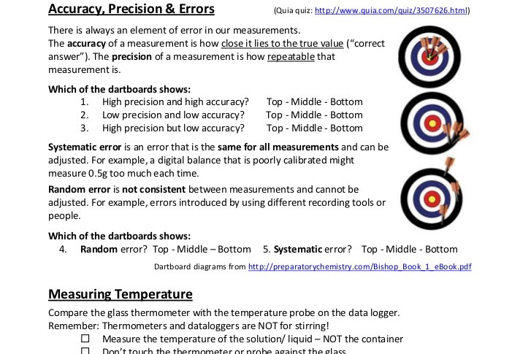

**Mental Reps Through Training**

Most people do not see skeletons during their day to day lives. As such when learning about the human body it can be incredibly helpful to use skeleton mockups and software to develop a mental model of what lays beneath the skin. This is an example of an online interactive exercise that helps visitors learn prominent bones of the human body. The [website itself](https://online.seterra.com/en-an/vgp/3800) follows pre-existing software mental models about how objects on the screen should interact when clicked.

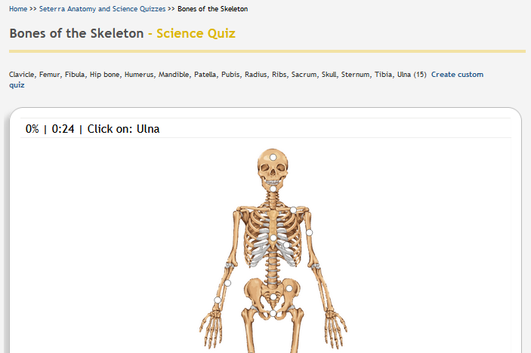

**Many games follow a familiar pattern**

Minecraft, one of the most popular computer games of all time, can be utilized for a variety of learning outcomes. Using Minecraft for education capitalizes on mental models in a couple of ways. It speaks to the student in a language that many of them already understand and are drawn to, thereby lowering the barrier of entry for new concepts that can be introduced in a familiar setting. Minecraft itself follows several established gaming patterns for the user interface, navigation, and gameplay, which makes it easy for new players to pick up and understand.

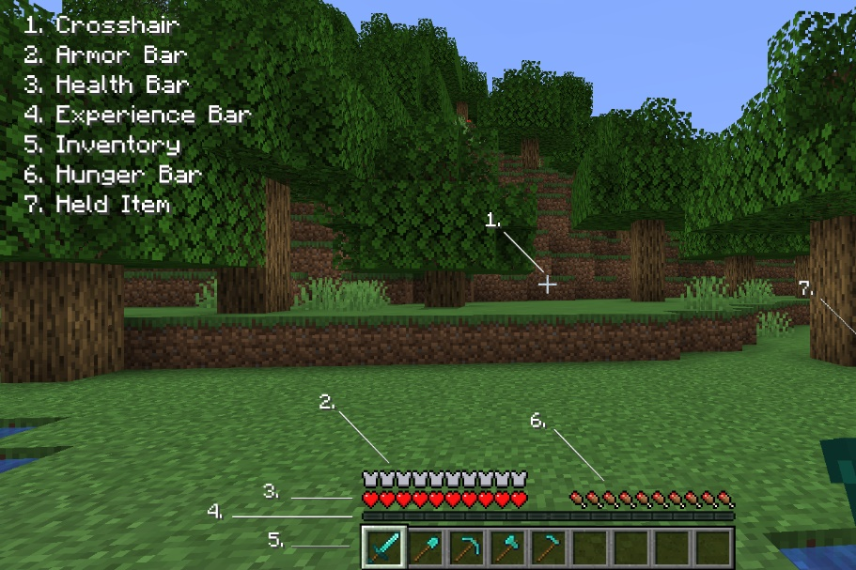

**Play to learn**

Both Robot Turtles and Scratch are examples of games that help beginners learn fundamental coding concepts. They help the learner create mental schemas for concepts that may seem otherwise overly abstract. Scratch in particular is a stellar example because of its intuitive design, explanations, and interaction. Robot Turtles was a successful Kickstarter, and Scratch was developed by MIT and is free for public use.

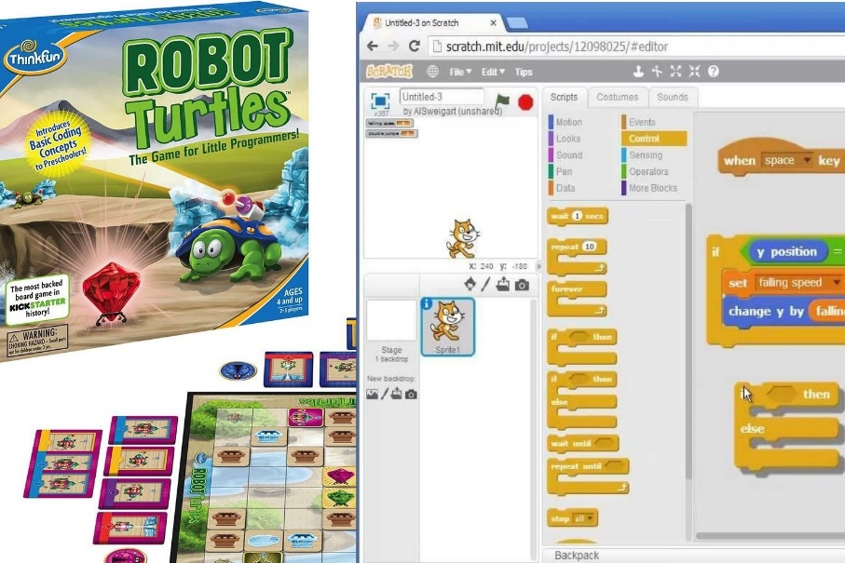

**Web interfaces**

Flat UI and Bootstrap 4 are CSS frameworks/libraries that illustrate examples of interface components that follow common conventions and present the user information in a manner they are likely comfortable with. The buttons, sliders, forms, and other components fit with the mental model most users have for websites. This website for example is built using the Bootstrap 4 library, which was originally developed by Twitter and then open-sourced. However, the fact that these components are so familiar may be considered a drawback when going for a unique look. Although, it is more important to be understood than to be impressive, as one of my favorite professors said.

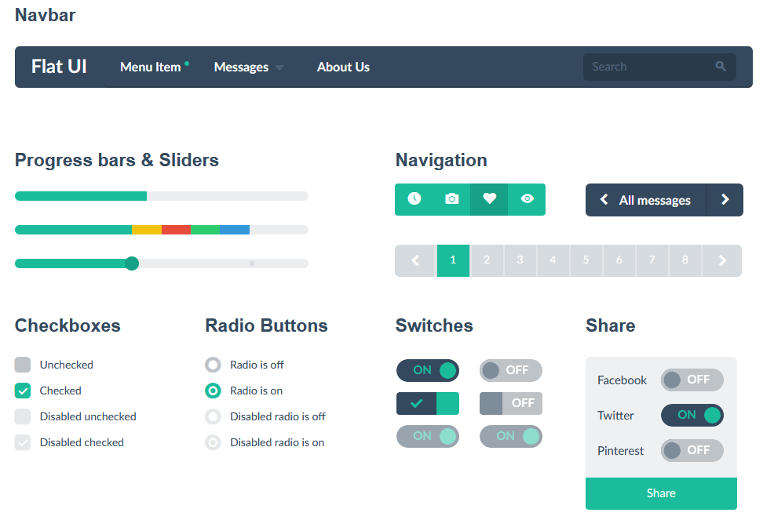

Duane Gregory - WTAMU course 6310 - Summer II - 2020